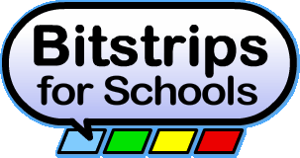
Bit Strips for Schools Introduction

The following assignment will introduce you to the online comic creation website known as Bit Strips For schools. The first assignment’s purpose is to familiarize you with the creation tools contained on the site. This particular assignment will be assessed for completion, but you should aim to complete the assignment to the best of your ability, as the next assignment will be evaluated (assessed for marks). In order to access your account please complete the following:

- Go to the following website: www.bitstripsforschools.com
- Choose Log In in the upper right hand corner
- Under student, enter the code: Shazam!
- Choose your name from the dropdown list.
- You will be prompted to enter a password. Please choose one you will remember and write it down here in case you forget ________________________________
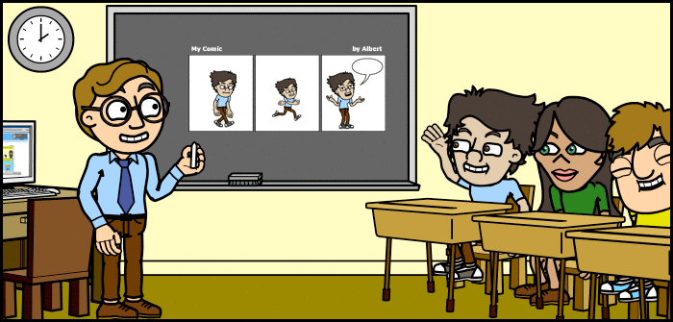
- After logging in, in the lower left it says “1 Activity to Complete: My Life in a Comic”. Click on it and follow the directions.
Note: When everyone signs in at once, the site will slow down. Please be patient; you may have to wait for a few minutes.

